Document Title: | TVCA Group Procurement Policy
Document Number: | P73
Document Author: | Procurement
Document Status: | Approved
Document Authorised Date: | 29/11/2023
Revision number: | Revision 0.2
Next Review Date: | September 2024

CONTENTS

- Purpose & Introduction
- Objectives
- Minimum Standards for Commercial Activity
- Authority Levels, Delegations & Governance
- Business Case Requirements
- Markets
- Procurement and Finance Involvement in Contracting Decisions
- Use of Frameworks and Other Pre-arranged Contracts
- Tender/Quote/Competition Requirements
- Direct Award of Contracts
- Contract Management
- Contract Extensions or Expansion
- Exit Arrangements, Continuity & Contingency
- Intellectual Property in Deliverables
- Social Value (Corporate Social Responsibility)
- Standards & Fairness
- Confidentiality
- Record Keeping & Freedom of Information
- Retention Policy for Tender and Contract Documentation
- Small and Medium-sized Enterprises
- Early Market Engagement (EME)
- Transparency
- Glossary of Terms
Appendix A – Procurement Thresholds Table Appendix B – High Level Process Flow
Appendix C – Scheme of Delegation

DISCLAIMER
Has the document been considered for equality implications against protected characteristics as defined in the Equality Act 2010? (Age, Disability, Gender Reassignment, Marriage & Civil Partnership, Pregnancy & Maternity, Race, Religion of Belief, Sex, Sexual Orientation)

Purpose & Introduction

Procurement is defined as ‘the process of acquiring works, supplies, or services from third parties. The process spans the whole cycle from identification of needs, through to the end of a service contract or the end of the useful life of an asset.

This policy outlines the principles by which Tees Valley Combined Authority Group (the ‘Group’) entities will comply with their statutory and regulatory requirements in relation to procurement and has been produced following approval of the ’Group’ Procurement Strategy in July 2020.

The purpose of having a ‘Group’ policy is to ensure effective procurement processes are adopted across all the ’Group’ entities, helping us to maximise value for money, promote social value and improve efficiency. This means, adopting a transparent and competitive approach to procurement wherever practical to do so.

The policy has been developed to ensure appropriate and proportionate approaches to procurement procedures are adopted for all levels and types of spend from small direct purchases through to major development contracts.

But procurement is not only about legal compliance. The ability to achieve the greatest value with public spending can only be achieved when suppliers engage with us. They will only do this when they trust our systems and processes to produce a fair outcome and when they get good quality feedback to support them to improve their bidding practices for the future. Openness and Transparency unpin our reputation.

Objectives

The objectives of the policy, are:

- To provide clear guidelines and methods by which ‘the ‘Group’’ procure, services goods and works
- Award contracts that achieve best ‘Value for Money’
- Promote robust contract and supplier management systems
- To ensure that social value is considered and explicitly evaluated via the procurement process where appropriate
- Promote open and transparent competition
- Encourage market engagement

Minimum Standards for Commercial Activity

This policy applies to all TVCA employees or their representatives who are engaged in procurement activity, where they are required to be aware of the policy and associated legal Acts and Statutory requirements along with any subsequent amendments, which include but are not limited to:

- Public Contract Regulations 2015
- Utilities Contracts Regulations 2016
- The Social Value Act 2013
- Modern Slavery Act 2015
- Bribery Act 2010
- Equality Act 2010

In addition to regulatory responsibilities ‘Group’ employees or their representatives must also:

    - Ensure fair and open competition and be able to demonstrate equitable and consistent evaluation of tenders/bids.
    - Consider equality issues as early as possible in the procurement process.
    - Explicitly evaluate social value as part of the process where required
    - Justify the use of any direct awards and keep their use to a minimum.
    - Make sure contracts are appropriate up to date and executed with legal sign-off and,
    - Inform the Procurement Team as early as possible when considering any procurement of works, goods, and services for consultation.

Procurement should be carried out using defined and standardised procurement processes which cover the whole 'purchase to pay' cycle. The most efficient and appropriate methods should be used which are proportionate to the value of the contract.

Business procurement activity should be underpinned by an understanding of the cost benefits and risks. Completion of the Procurement Approval form with business case information is mandatory for all spend above £5000, with consideration given to cases above the thresholds detailed in Appendix B.

All contracts must be based on the Appropriate ‘Group’ Standard Terms and Conditions, or model contract forms such as NEC, unless it is commercially necessary to agree otherwise (i.e., bespoke contract terms). The ‘‘Group’s’’ legal and/or the procurement business partner can advise which terms of contract to use.

Upon execution of the contract the procurement team member responsible will post a contract award notice on Contracts Finder for contracts over £25,000 and also on Find a Tender Service for contracts above the threshold within 30 days of the contract being signed by both parties.

Authority Levels, Delegations & Governance

The Group has developed schedules which describe the delegation of financial and non-financial decisions in the organisation. Such delegated authorities must be followed, and approvals documented using the Procurement Approval form.

Appendix C (Scheme of delegated authority document) sets out the scheme of delegation approval limits for the various ‘Group’ entities. These delegations ensure a separation of duties between budgetary authority and procurement authority.

The ‘Group’ places trust in its employees to avoid even the appearance of impropriety and it is important that a clear segregation of duties can be demonstrated by close adherence to the scheme of delegation. It is also essential that employees of the ‘Group’ adhere to the Antifraud and Corruption Policy at all times. Training on managing public money and use of the ‘Group’s’ Conflict of Interest Register should also be promoted.

Business Case Requirements

The Procurement Approval form must be completed for all procurement over £5,000. The latest version can be obtained from the procurement team. These can be reviewed for compliance by the Procurement team and or relevant Manager. Before being sent for sign off via the approvals process using the email address TVCAPAs@teesvalley-ca.gov.uk by procurement.

Markets

When planning procurement and making commercial decisions, the ‘Group’s’ employees should be aware of current market conditions for the product or service they are procuring. Employees should also consider longer-term market development when making procurement decisions to ensure suppliers continue to meet the ‘Group’s’ commercial needs.

Where appropriate market engagement should be carried out, which should be proportionate to the value and complexity of the contract and consider any related risk. Consideration should also be given the various tools & techniques which can be used which include but are not limited to:

    - Prior Information Notice (PIN) for market stimulation
    - Request for Information document (RFI) to understand the size and appetite in the market and help develop the scope and understand risk.
    - Market engagement event, to explore further information gleaned from the RFI

Procurement and Finance Involvement in Contracting Decisions

Effective commercial decision making is essential. Individuals must have the right experience, training, expertise, and capacity to ensure that minimum standards of commercial practice are met. They should have the knowledge of the product or deliverable being purchased and the market of potential suppliers and their procurement should comply with legal requirements and best practice. Procurement training may be provided, if necessary, on request and support from the Procurement Team will be available during the tendering process.

Line managers and anyone involved in making purchases must demonstrate compliance and good practice.

It is particularly important that the ‘Group’ maximises the benefits of effective procurement in the letting and management of major programmes. For larger procurements (over the EU Threshold), it is essential to involve Procurement as early as possible:

- Where appropriate, in annual planning and budgeting.
- When considering the market, the legal environment and agreeing the nature of the competition.
- When developing the specification, e.g., to ensure it is output based and does not inappropriately include propriety products etc.; and,
- From the start of the contracting process; it is difficult for professional procurement to add any value when presented with a fait accompli requisition or contract.

Irrespective of value, any potential requirements for changes to the ‘Group’s’ standard goods and services terms and conditions must be raised with t h e p r o c u r e m e n t t e a m for advice and escalation for legal input. This includes any suggested amendments to the ‘Group’s’ standard indemnity and insurance clauses.

The procurement team must also be informed of any potential and actual disputes with suppliers (pre or post contract) as soon as you are aware of them.

Use of Frameworks

National and Regional Supplier Frameworks/Catalogues

Where similar goods or services are repeatedly required, frameworks should be used where these are in place.

The ‘Group’ will make use of National and Regional Supplier Frameworks/Catalogues, (such as CCS or NEPO) where appropriate. The benefits of such frameworks are that they leverage wider public sector total spend, optimise VfM, help ensure quality of materials and reliability of supply, reduce the associated transaction costs, and enable much faster award of a contract.

There are several government contracts available for the ‘Group’ to use, and employees should use these contracts as appropriate. Procurement can advise if your specific requirement can be covered by such a contract or framework when provided with an informative specification.

Framework contracts should be used in accordance with the specified call off procedures. Some frameworks contain multiple suppliers e.g., Crown Commercial Services consultancy frameworks. In these cases, further competition betweensuppliers on that framework may be necessary; Procurement can provide advice on how these should be used.

Upon execution of the contract the procurement team member responsible will post a contract award notice on Contracts Finder for contracts over £25,000 within 30 days of the contract being signed by both parties.

Our Frameworks (Panels)

Sometime better VfM and regional outcomes can be achieved by the ‘Group’ setting up its own frameworks. National frameworks may not be suitable (due to specialist requirements for example). The costs/value of setting up and running such frameworks are important considerations. When we set up a new framework, we can include other authorities who can buy from the framework. We will always include all ‘Group’ entities and the 5 Tees Valley Authorities as contracting authorities.

Tender/Quote/Competition Requirements

Different levels of competition apply depending on the value of the contract being placed and the type of goods, service and works to be supplied. All values relate to total whole-life aggregated contract spend.

Where goods, services or works are to be procured and no framework agreement or pre• negotiated contract exist, there are various procedures that can be applied, as described in Appendix B.

Direct Award of Contracts

Competition between prospective suppliers is the best way we can secure and demonstrate value for money and comply with legal requirements. It reduces the risk of selecting an unsuitable supplier, almost always secures a better deal and avoids suggestion of improper or illegal behaviour by The ‘Group’s’ employees.

However, in exceptional circumstances a product or service may be procured without competition - if supported by a robust business case. Lack of time, unless in the case of a National Emergency (e.g., Foot & Mouth outbreak), is not an acceptable reason.

All requests must have a robust justification in the business case and/or Procurement Approval Form, and they must be approved by relevant members of the business, i n c l u d i n g C h i e f L e g a l O f f i c e r a n d according to the scheme of delegation shown in Appendix C.

As part of the direct award process, suppliers must sign and return a form of tender indicating their acceptance of the appropriate Terms and Conditions of contract for the service, works or goods being procured.

Upon execution of the contract the procurement team member responsible will post a contract award notice on Contracts Finder for contracts over £25,000 and on Find a Tender Service for contracts above the threshold within 30 days of the contract being signed by both parties.

Contract Management

Effective contract management is essential to meet project deadlines, save taxpayers’ money and strive for more sustainable procurement. Monitoring and sharing project progress through consistent contract documentation management is also integral. The larger and more complex the project, the greater the need for rigorous contract management.

To kick off the contract management process and start to develop relationships with suppliers a contract initiation meeting should be arranged following contract award. The purpose of the meeting is to:

- Verify the contract particulars
- Agree reporting requirements
- Agree mobilisation of the contract
- Confirm contract manager and appointed person(s) to authorise spend

No purchase orders should be raised against the contract until it is executed. Only in exceptional circumstances will a purchase be raised, which can be done via a letter of intent signed by the Chief Legal Officer or their Deputy.

Contract Extensions or Expansion

Many major contracts will change their nature over their term. Similarly, the total contract value may not be precisely what is originally planned. However, there are risks in either case e.g., risk to value for money, ensuring suppliers have the right competences, or even risk of anti•competitive behaviour.

The EU has frequently acted against organisations that extended contracts when there should have been fresh competition.

If the value, duration, or scope of a contract appears likely to increase or change, Procurement must be consulted beforehand, and will provide advice and determine the level of risk.

To be noted that contracts that are subject to PCR 2015 should not automatically be extended and cannot be extended more than 50% of their original contract value. The ability to extend up to 50% should be assessed by procurement and must be in line with the regulations and in line with what was originally advertised to the market.

Exit Arrangements, Continuity & Contingency

It is essential to consider the contract exit arrangements, as early as possible to ensure continuity of service and plan for contract expiry.

Intellectual Property in Deliverables

When placing contracts, very careful consideration must be given to both the short- and long-term outcomes, to ensure the ‘Group’s’ interests are protected. No one bidder or contractor should be given any commercial advantage because of early access to project Groups, information, or planning.

For the same reasons, all contracts which may involve the development of intellectual property such as ideas, techniques, designs, reports, plans or software (this list is not exhaustive) where public funding is used, must specify where the ownership of these rights will rest. The technical phrase for this is vesting the Intellectual Property Rights (IPR).

The ‘Group’ would always expect to vest the IPR, and suppliers should be asked to sign a non•disclosure agreement, where appropriate to protect the ‘Group’s’ IPR.

Any discussed changes to the ‘Group’s’ standard terms and conditions relating to IPR must be raised with Procurement, for advice and escalation for legal input, and agreed to internally as per the scheme of delegation, prior to any amendments being agreed.

- Social Value (and Corporate Social Responsibility) Our ‘Group’s’ Commitment
The ‘Group’ is committed to procuring goods and services in an environmentally responsible and sustainable way. Wherever possible, products and services purchased should be manufactured used and disposed of in an environmentally responsible way. Considering whole life costs will often secure a better deal and improve the sustainability of what we buy.

The group has set out a roadmap to achieving net zero in tees valley by 2050, and we recognise that procurement has a role to play in that journey.
We intend that Procurement, and the Group will leverage our position as a major regional procurer of goods and services to embed net zero goals in our purchasing

Taking these opportunities offers benefits in environmental, social, and economic terms across the public sector, business, and wider society. Where appropriate, tenderers should be asked to set out in their proposals what contribution they will make to efficiency and sustainability if awarded the contract.

Our detailed approach to delivering Social Value can be found in our ‘Group’ Social Value Policy. This policy addresses such things as:

- Sustainable procurement, for instance, embedding sustainable development considerations into spending and investment decisions across the ‘Group’, can offer many opportunities including:
    - avoiding adverse environmental impacts arising in the supply-chain by, for example, reducing waste and emissions.
    - making more efficient use of ‘Group’ resources, for example, through reduced energy consumption and reduced packaging.
    - stimulating the market to innovate and to produce more cost effective and sustainable options for all purchasers; and,
    - setting an example for business and the wider public and demonstrating that The ‘Group’ is serious about sustainable development.

Social Value Act 2012 – Our Suppliers

The ‘Group’ will work to ensure Social Value is obtained through the commitment of public funds.

We will seek to improve economic, social, and environmental wellbeing from our contracts, over and above the delivery of the services directly required, and at no extra cost

Where appropriate there will be a mandatory weighting for social value contribution for all tenders over £100,000. This will consider a minimum of 20% to establish supplier responses with an ambition to increase the weighting going forward to ensure that Social Value becomes embedded in the procurement process. The procurement policy will detail the principles for applying weightings for social value.

Standards & Fairness

All procurement should be carried out in accordance with the ‘Group’s’ procurement and financial policies and all employees should be able to demonstrate compliance within their role as purchasers and contract managers.

Care must also be taken where suppliers with strong knowledge of the ‘Group’ - such as incumbent suppliers - bid for work. It is important that such potential suppliers do not receive or expect to receive special consideration. If any supplier's 'inside knowledge' could appear to give them an unfair competitive advantage, it is essential to consider and set out what arrangements need to be put in place to be able to demonstrate a level playing field in a competition to meet legal requirements and secure VFM through a fair and open competition process among all suppliers.

Confidentiality

The ‘Group’ must respect the confidentiality of technical and commercial information provided by suppliers to the extent that Freedom of Information Act 2000 (FOIA), the Environmental Information Regulations 2004 (EIR), the Data Protection Act 2018 and other statutory obligations or subsequent amendments or new legislation permit.

All suppliers and potential suppliers are expected to reciprocate in respect of commercially sensitive information provided by the ‘Group’. To protect against

disclosure and unauthorised use of confidential information, suppliers are to be asked to sign an TVCA ‘Group’ non-disclosure agreement where appropriate.

In particular:

- employees must not divulge any confidential information, including personal data or information, to any unauthorised person or persons; and
- controls must be in place to ensure that unauthorised persons do not obtain such confidential information.

If in doubt as to whether information is confidential or not, please contact Procurement to obtain legal advice.

Record Keeping & Freedom of Information

The method of supplier selection must be fully documented and saved in accordance with the ‘Group’s’ naming conventions -to allow full and open review of the decision-making process at any time. This will include the selection process used and the selection criteria (financial status, price, expertise, uniqueness, etc.) weighted according to the authorised purchaser's needs. This record should be logged and kept on file and be made available to internal auditors, external auditors, and procurement upon request.

Under FOIA, EIR and DrA, the ‘Group’ is required to maintain sufficiently robust and effective information handling procedures. In practice this means that all colleagues have a responsibility to maintain accurately named and numbered files, using up-to-date, clear, and systematic cross-referencing. All requests from the public relating to disclosure of information under the FOIA and EIR must be managed in accordance with the relevant handling procedures set out in the Document Control Policy.

In addition, it should be noted that to comply with legal requirements, contracts, purchase orders and all associated documents must be retained in accordance with the ‘Group’s’ Document Control Policy.

Retention Policy for Tender and Contract Documentation

Contracts should be retained for a period of six (6) years after the completion of the contract, or 12 years if the contract has been executed as a Deed.

Expressions of Interest and/or Pre-Qualification Questionnaires should be retained for one (1) year from award of contract.

Unsuccessful Tenders should be retained for one (1) year from award of contract.

Tenders submitted where the decision to abandon the exercise was taken and no contract was awarded should be retained for one (1) year from the date that the decision was taken.

Small and Medium-sized Enterprises

The Government is committed to ensuring that SMEs can bid for public contracts. The Cabinet Office expects public sector bodies to follow the European Commission definitions:

- Medium sized means no more than 250 employees, a balance sheet that does not exceed £35.4m and/or turnover that does not exceed £41.4m.

To encourage SME participation in public sector contracts, we are required to:

- eliminate the use of Pre-Qualification Questionnaires (PQQ) for all procurements under the EU threshold where possible and select the most appropriate route to market based on the individual requirement.
- use the standardised PQQ, with the objective of ensuring.cross- Government adoption of a shortened/less onerous PQQ template.
- move towards greater use of the "open procedure" for larger projects; and,
- encourage prime contractors to consider SMEs when putting in'place sub- contracting arrangements.

Early Market Engagement (EME)

EME comprises all the activities undertaken to engage with the market before commencing a procurement process. It is a method of capturing intelligence on innovations, new processes, project feasibility and market capacity/capability which can then be factored into the speciation and procurement.

Cabinet Office rules now encourage pre-procurement and EME for all EU-covered procurement to foster innovation and assist SMEs.

Early pre-market engagement enables purchasers to better define their requirements and reduces their reliance on complex procurement procedures.

Transparency

Contracts between £25,000 and threshold (see appendix B for current thresholds) should be advertised openly if not using a framework or understand the market sufficiently to carry out an Invitation to Quote process. All contracts over the threshold should be advertised openly unless using a framework, where the specific framework rules must be applied.

A framework is the preferred first option for procurement. If procuring from a framework with a value above £25,000 then a contract award notice must be placed on Contracts Finder. (See above in relation to Utilities).

If no framework is available, the requirement should be advertised on Contracts Finder (above £25,000 and up to threshold), (See above on Utilities), (and on Find a Tender Service (FTS) if above the required threshold. The contract award notice must also be published on Contracts Finder and where relevant FTS.

Glossary of terms

Anti-corruption
Activities that oppose or inhibit dishonest, fraudulent, or criminal conduct. These activities can include anti-corruption education, introduction of anti-corruption compliance programmes, and collective action on anti-corruption legal frameworks which cover bribery and money laundering.

Benchmark
Compare an element of one business, such as price, quality, or service, against another.

Category Management
A strategic approach to procurement that segments and aligns spend with each supply market allowing greater focus on value creation.

Chief Officer
Refers to any responsible Chief Officer of the ‘Group’ as detailed in the scheme of delegation
– Appendix C.

Compliance
Conforming to rules and regulations.

Contract Management
Managing the contracting cycle from establishing the business need to reviewing performance.

Contract Regulations
Laws and guidelines that ensure contracts are handled fairly within a jurisdiction.

Corruption
Abuse or misuse of a person’s entrusted position, power, or authority for personal gain. In procurement, this could include a person with authority agreeing to give a specific supplier a contract before a fair competitive tender has been carried out (making it unfair).

Delegated authority
Giving another party the responsibility of carrying out the acts agreed to in the contract

Direct call off
The act of placing an order under a framework agreement without having further competition.

Dynamic Purchasing System
Agreement which allows purchasers to order supplies, services, or works under the terms and conditions specified in the DPS. Additional parties can apply to join onto the DPS if they meet the selection criteria.

Early supplier involvement (ESI)
The involvement of a supplier in the product development process from a very early stage in order to use the supplier’s experience and expertise

E-auctions
Auctions where the bidding takes place on the Internet

E-catalogue
An electronic catalogue supported by Internet ordering and payment capabilities

E-procurement
Electronic systems supporting the phases in the procurement cycle from contract award to asset management.

E-tendering
An electronic approach to tendering using e-mails or portals

Ethical Procurement
Ensuring that products and services are obtained in a responsible and sustainable way that demonstrates respect for people involved in the supply chain and the environment such as fraud, corruption, bribery, modern slavery, human rights.

Framework Agreement
An agreement that allows purchasers to order supplies, services, or works under the terms and conditions of the agreement (it provides a mechanism for calling off orders as and when required).

Fraud
The overarching descriptor that covers both bribery and corruption. Fraud is the intentional act, omission, or misrepresentation with the aim of misleading another party for financial gain. The World Bank define fraud as ‘the abuse of public office for private gain.’

GDPR
The European Union’s General Data Protection Regulation

Invitation to tender (ITT)
A structured process requesting a supplier to provide a bid against a specified set of terms, usually to carry out a service, by a stated deadline

Invitation to treat
Document inviting potential suppliers to quote for business

Key performance indicators (KPIs)
A quantifiable measure that can be used to assess performance over time. Often in supplier contracts KPIs will be set around many factors such as quality, cost, and delivery

Key stakeholders
Individuals or organisations who will be directly affected by a decision

Letter of intent (LOI)
A letter sent from one business to another which summarises the agreement reached during negotiations and provides the basis for a future or proposed contract. The letter expresses an intention to enter into a contract at a future date but creates no contractual relationship until the future contract has been signed

Life-cycle costing (LCC)
The process of understanding all costs that an asset will incur over its lifespan. This can include costs such as acquisition, running, repair and disposal

Market engagement
A process to gain advance understanding of the market prices or trends.

Mini-Competition
A limited tender exercise, usually only on price, under the rules set out in a framework agreement; only suppliers appointed to the framework are able to take part.

PCR 2015
Public Contracts Regulations 2015.

Pre-qualification questionnaire (PQQ)
A document sent to potential suppliers to find out their suitability to be included in the procurement process.

Prior information notice
A notice released by a buying organisation through the OJEU to make potential suppliers aware of a sourcing competition that it intends to run in the future.

Purchase requisition (PR)
An instruction or authority given to allow a purchase order to be raised.

Purchase to pay (P2P)
A sequence of procurement processes from the procurement of a product or service through to the completion of the financial transaction to pay for it.

Reputational damage
The loss in financial or shareholder value resulting from damage to an organisation’s reputation which may arise through bad publicity, negative information or an adverse or criminal event, even if found not guilty.

Request for information (RFI)
A document used to gather information about suppliers and their capabilities prior to a formal procurement process.

Request for proposal (RFP)
A document used to canvass potential solutions from suppliers when the specification is still unclear.
Organisation Document title Revision Approved by:

Group | Procurement Policy P73 | 0.1 | PJ & Directors

Request for quotation (RFQ)
An invitation to suppliers to bid on specific products or services.

Restricted tender procedure
Two-stage process where suppliers are selected prior to being invited to bid.

Scope
Refers to the boundaries of the project; it defines what the project will deliver and what it will not deliver.

Scope creep
Changes in the scope or requirements of a project over time, without authorisation and usually without adjusting for additional time, resources, or money.

Social value
The output from a contract that benefits society at large, rather than the purchaser or end user (sometimes also called community investment or corporate social responsibility).

State aid/ Subsidy Control
‘state aid’ or subsidy control - covers subsidies or other governmental measures (such as tax benefits) to support a particular organisation or industrial sector.

Sustainability
Supporting future ecological balance by not harming the environment or depleting natural resources.

Sustainable Procurement
Procurement which supports the sustainability goals of the organisation and optimises the environmental, social, and economic impacts over the life cycle of the product or service.

Value for money (VFM)
Value for money is archived by the optimum combination of economy, efficiency and effectiveness. In the acquisition of goods, services and works this is usually reflected in the most advantageous combination of price and quality that makes a product or service fit for purpose and will achieve the buyer’s required outcomes. This needs to be viewed in terms of whole life costs of the Good, Services or Work 9 so for example it may be better value to specify a more expensive product that will last longer or have lower maintenance costs. .

Appendix A: Procurement Thresholds Table

New Thresholds1/1/2022 | Supplies & Services | Works | Light Touch
PCR 2015
Plus VAT | £214,904 | £5,372,609 | £663,540.00
Minus VAT |  |  | £552,950.00
Utilities 2016
Plus VAT | £429,809 | £5,372,609 | £884,720.00
Minus VAT |  |  | £737,266.66

Appendix B: High Level Process Flow

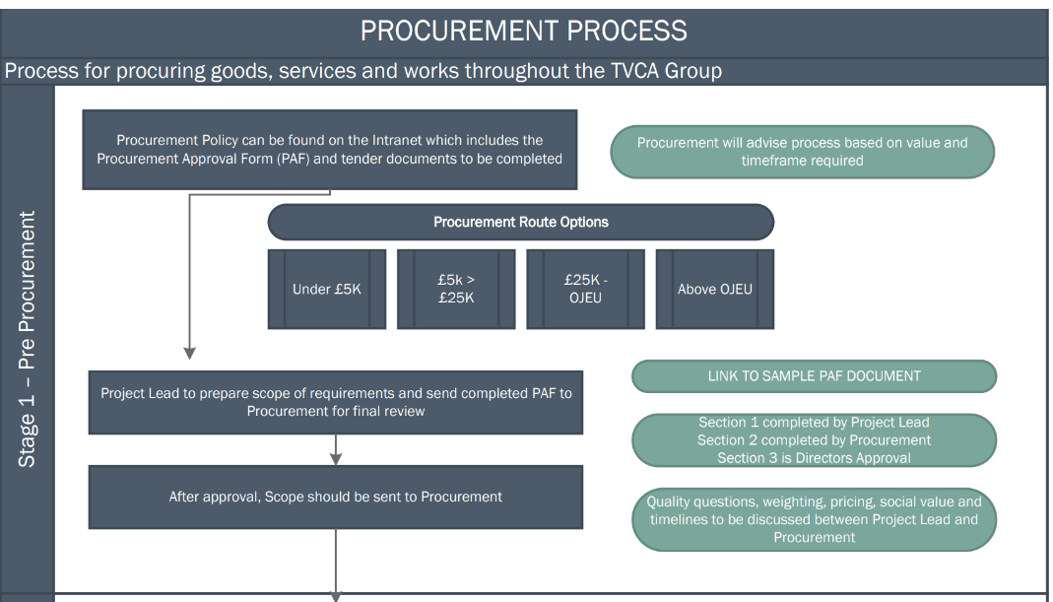
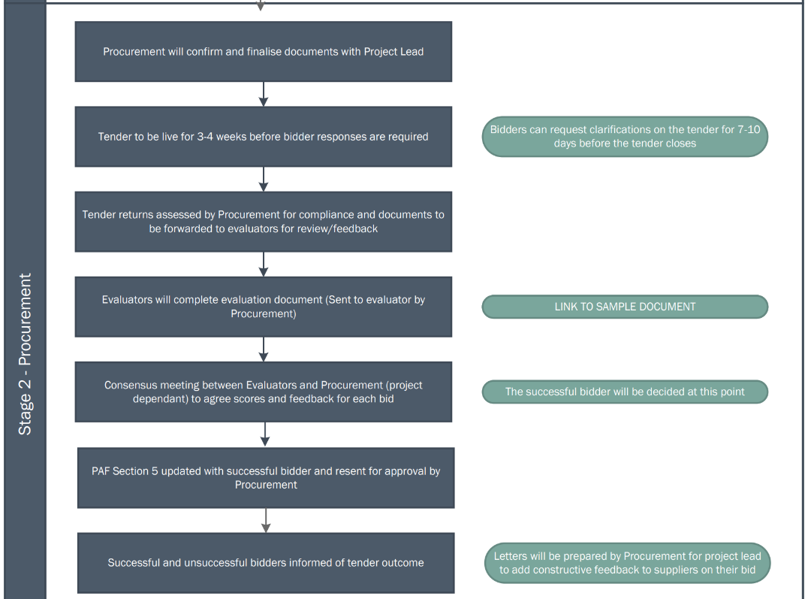
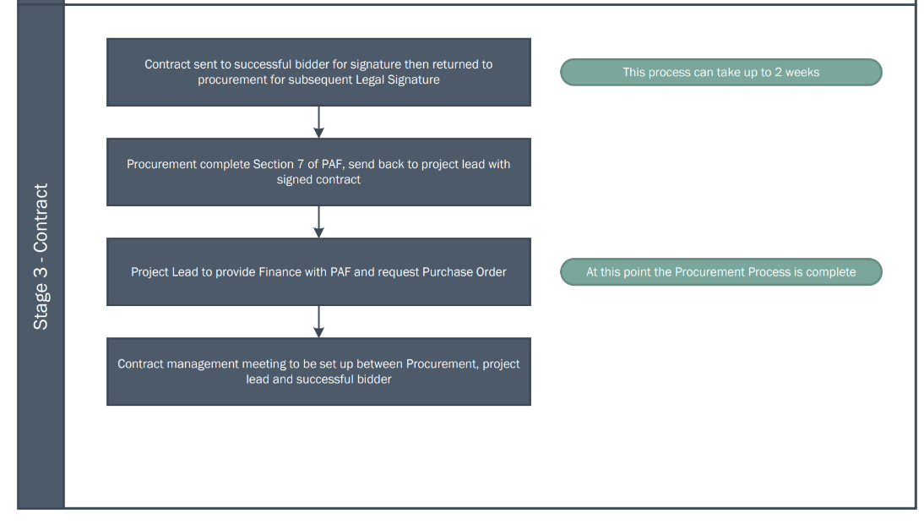

Appendix C: Scheme of Delegation

